#### Profile service

public class CustomProfileService : IProfileService

{

public Task GetProfileDataAsync(ProfileDataRequestContext context)

{

List<Claim> claims = context.Subject.Claims.ToList();

//optionally check the reason why the profile service has been invoked

if (context.Caller == "ClaimsProviderAccessToken" || context.Caller == "ClaimsProviderIdentityToken" || context.Caller == "UserInfoEndpoint")

{

//Create a new claim called Age and assign a random value to it

//This claim can optionally be added only to selected tokens by inspecting context.Caller

claims.Add (new Claim("Age", new Random().Next(10, 20).ToString()) );

}

context.IssuedClaims = claims.ToList();

return Task.FromResult(0);

}

//check if a user has been de-activated / removed

public Task IsActiveAsync(IsActiveContext context)

{

return Task.FromResult(0);

}

}

<http://quartzsystems.com/downloads/core3/authorization.txt>

This must be added to the Identity Server project -> is this still an active user?

Policy based authorization – check this.

Policy handler – authorization handler should be registered and preferably they should be registered as singleton. Type is IauthorizationHandler.

Hosting ASP.net core on IIS.

All this while we were using IIS server. As it is cross platform, no IIS for LINUX.

By default for us it is IISExpress.

Every .net core comes with a built in server Kestrel.

All this while Kestrel was available for us to use.

Why do we have a web server built in ?

TO ensure that ASP.net core works in a common manner on Lunux platform or windows platform.

Hence the common web server. It handles all the request, Asp.net core works with.

IIS express

Kestrel web server----- App

For our application it doesn’t matter what is outside. IIS sends to to KWS

Nginx sends to KWS. (linux)… Apache…

The middleware works in the common single consistent manner.

KWS is always used. Not our choice.

Why do we even need IIS… internet can directly talk to KWS? Not a lot of performance improvement.. marginal improvement.

App

Kestrel web server

Internet

Or reverse proxy – takes traffic from internet and directs it to the KWS.

When we were using the IIS server, then it was acting as the reverse proxy by collecting the traffic from the internet then sends to the target (KWS) in this case.

((((Proxy means, takes traffic from the machine and sends it outside))))))))

Edge server configuration or Reverse proxy -> recommended is reverse proxy config. As it can act as a shield for the KWS. Can act as SSL termination. Reverse proxy can take the request and conever it to nnormal http request to the KWS.

In production env. Reverse proxy is recommended.

A lot of work can be offloaded to the reverse proxy by the KWS.

Reverse proxy is always the recommended way unless very very small application. Be it internet or intranet.

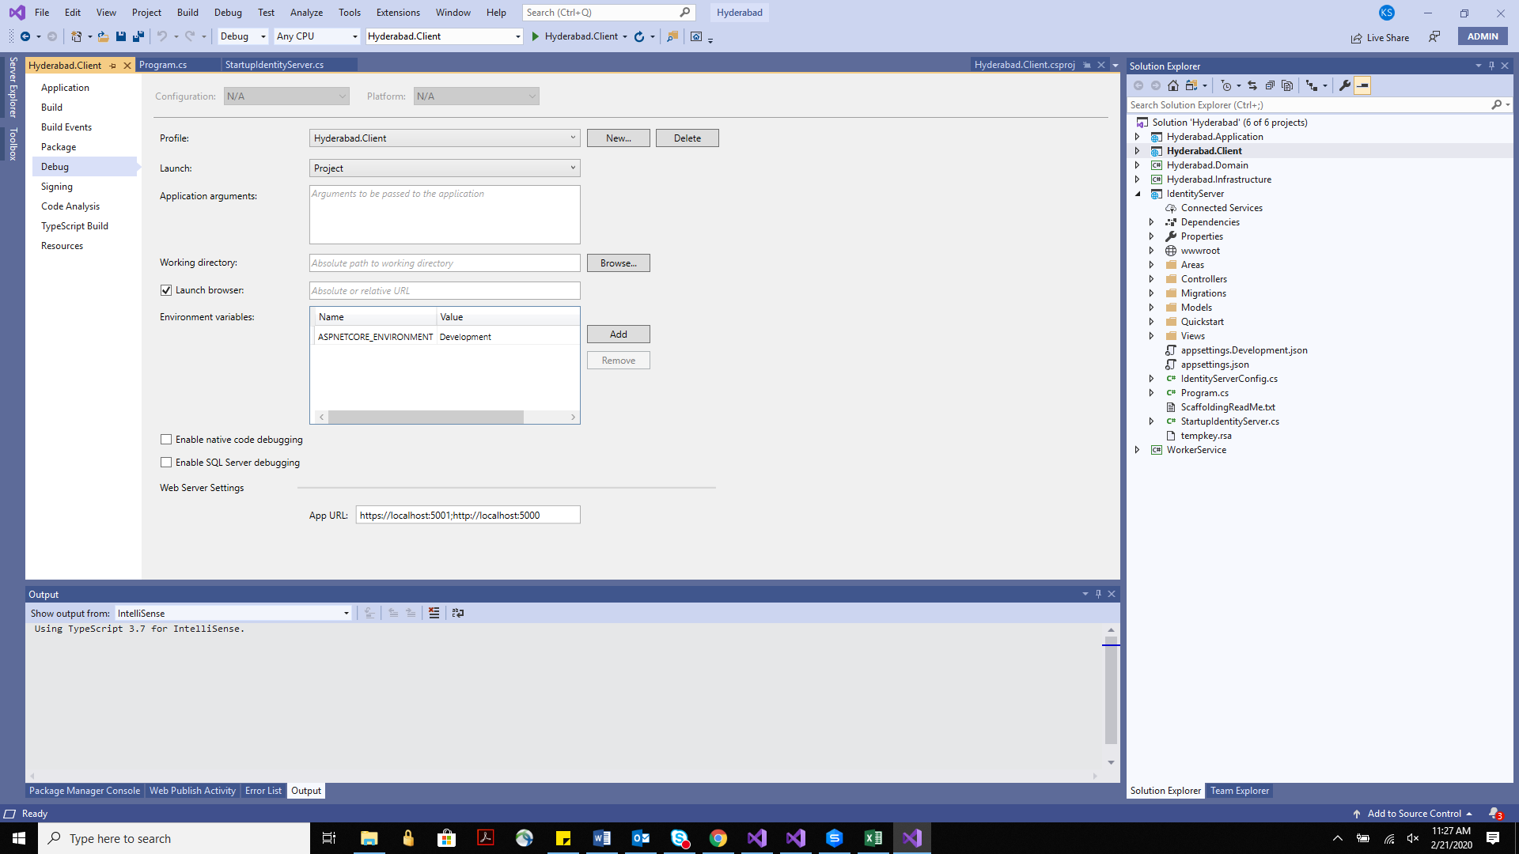

There is a console window athat opens simultaneously .. that’s kestrel.

Port changes on the browser different from IIS. Now kestrel.

We need to download a component to host in IIS. Module download.

In process hosting model. Out of process hosting model. – 2 types.

In process is the default.

Framework dependednt application or self-contained -> if framework dependent – then only project related dlls would be published. Framework level dlls should be there in the env. Like .net core 3.1

Target env. Will also neeed upgrade of the framework if at all application framework is changing.

Self contained -> no external dependency. All dlls contained.

=Target runtime -> portable, win-86 win-x64…

If you are not sure of the target env then portable is the best option.

…….

Edit the application pool to be of type no managed code.

Containerization:

Analogous to virtual machine.

Containers vs. virtual machine – check

Virtual machines can have multiple and dfffrent OS but containers rely on the OS of the machine.

Container engine facilitates the networking between the different containers on the machine.

Container engine also allows the container to talk to the OS. Docker.

You download packages like SQL on your machine.. need to configure as well.. good amount of time.

Alternatively, you can download the SQL server container. Smaller in size than installerandintalled version.

This way we are downloading a product that is already installed and pre-configured on the container.

It same like connecting to any other DB server.

Continaer are hosted at the container registry. Most famous in the container registry is Docker. Docker is a container engine.

Containers is a technology and industry standard is OCI. Docker os the company that pioneers in the continaer technology.

Its like a app store on the phone. If we want an app, we doenaload from Appstore.

If we want container we go to docker.

Private or Public container registry.

Image is nothing but a container that is not running.

Container is an instance of an image. Image is the object.

You can download an image (web server) and you can spin as many instances – as many containers based on the image.

Container orchestrator -> most famous is Kubernetes.

It manages the lifetime of a container.

Different types of components say -> Identity server, MVC, Web api products, web api orders, SQL, web api customer.

For load balancing we can have 2 containers each. Load handling we can have 5-6 contianers of the Identity server.

We need to keep monitoring how many containers are healthy… if new required, if one goes down.

Job of container orchestrator, the life of these containers management.

Create the configuration of number of containers for each component. And hand it to orchestrator. It will take care of number of instances required at any given time.

This is a YAML file.

Sql server docker container -> lets download.

<https://hub.docker.com/_/microsoft-mssql-server>

no GUI for docker .. everything is command based.

docker pull mcr.microsoft.com/mssql/server -🡪 run this on windows powershell.

To run the docker command, you need docker installed on your machine.

<https://hub.docker.com/editions/community/docker-ce-desktop-windows/> -- download docker for windows.

Docker compose is a poor man’s orchestrator.